**Create a new Gmail Account**

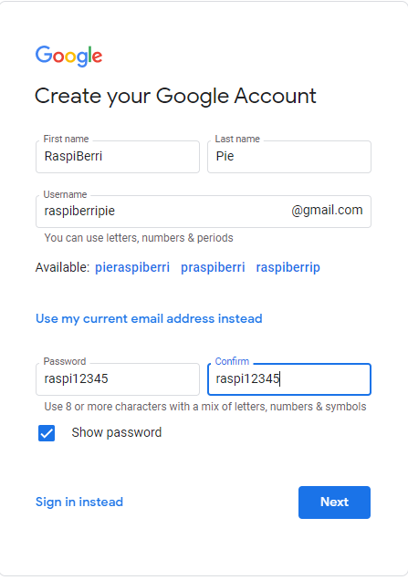

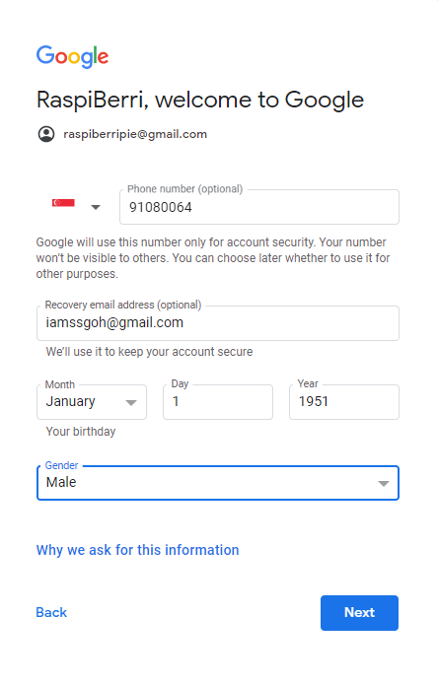

Click Agree to agree to the terms and condition

Open Browser

<https://myaccount.google.com/>

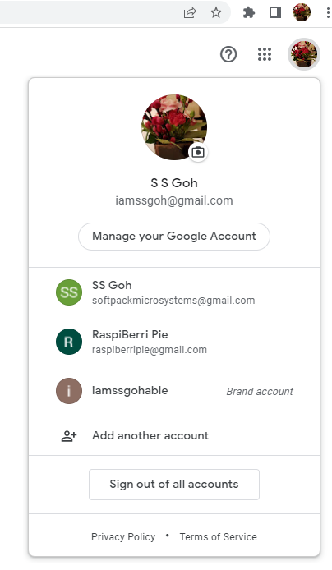

Select the new Gmail Account that you have just created.

For me it is raspiberripie@gmail.com

**Create App Password**

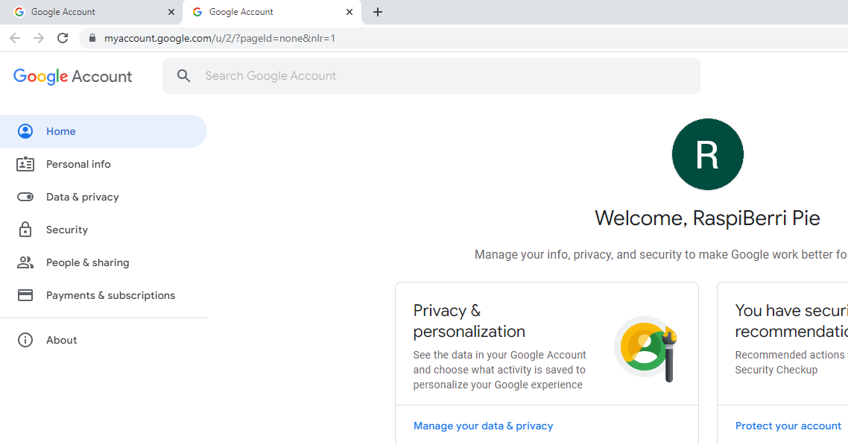

Click Security and look for 2-Step Verification

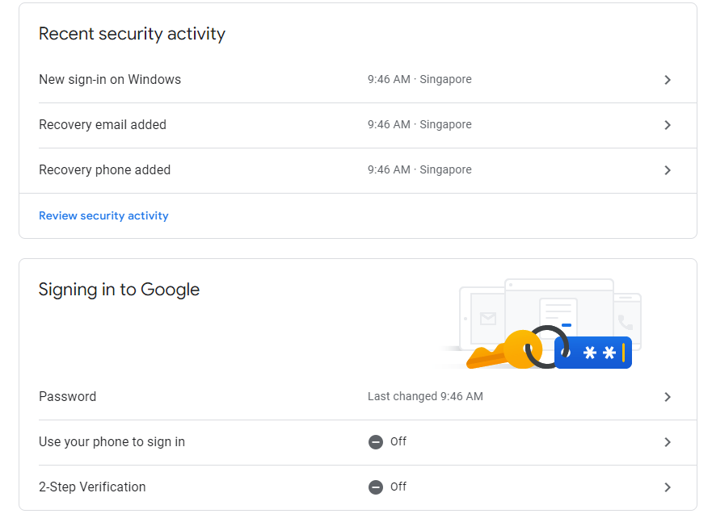

Click on the > to start creating the App Password

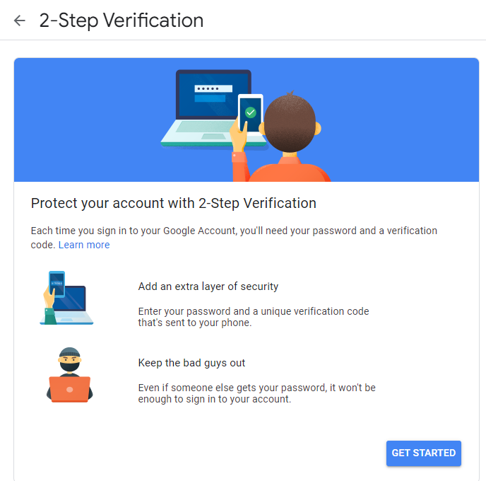

Click GET STARTED

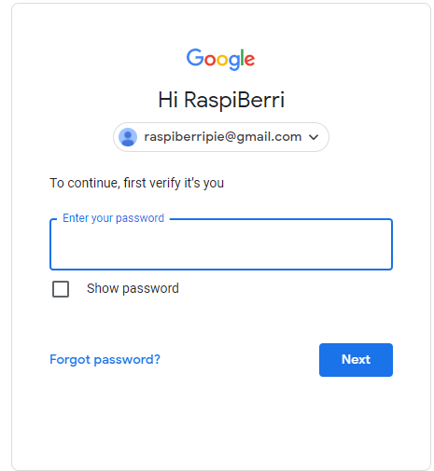

Enter the Password you have created for this Gmail Account. Mine is raspi12345

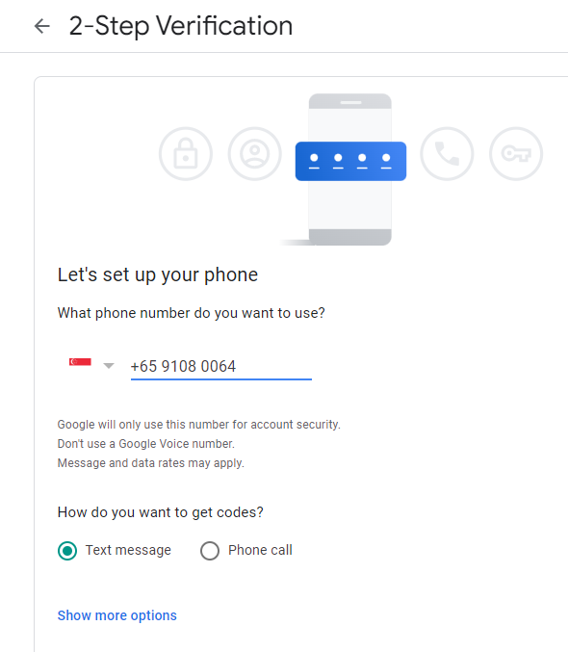

Enter your handphone No that you want Gmail to send your verification code to.

Select Text Message

Click Next

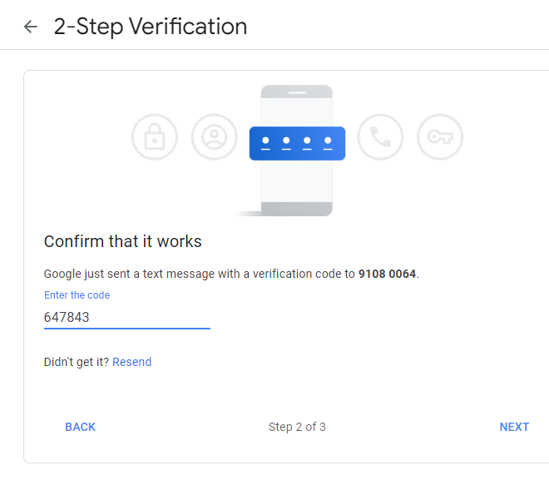

Enter the verification code you received via SMS. Enter only the numerals!

Click NEXT

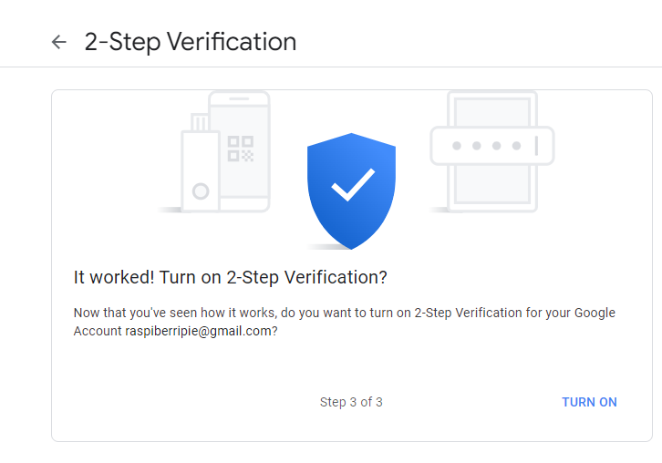

Click TURN ON

You should now see an App passwords option on your screen

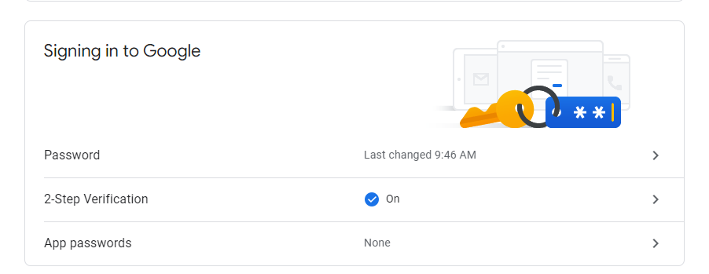

If you don’t, don’t worry.

Open your browser and browse to

<https://myaccount.google.com/u/2/security>

Select the new Gmail Account you have created.

Enter the password as prompted

Select Security on the left hand panel and you should see the screen above.

The App passwords is currently None. Click on the >

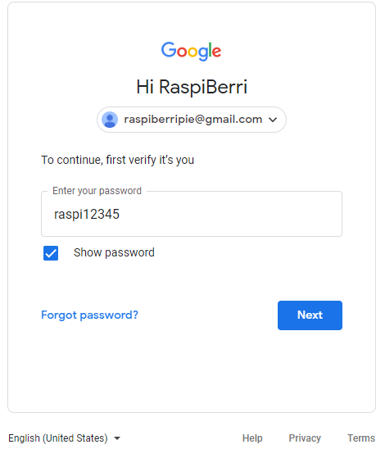

You will be asked again to login to this new Gmail Account.

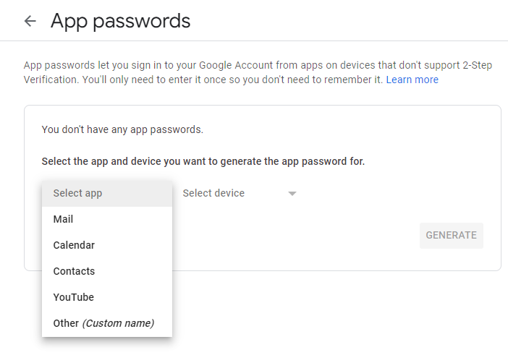

Click Select app

Select Other (Custom name)

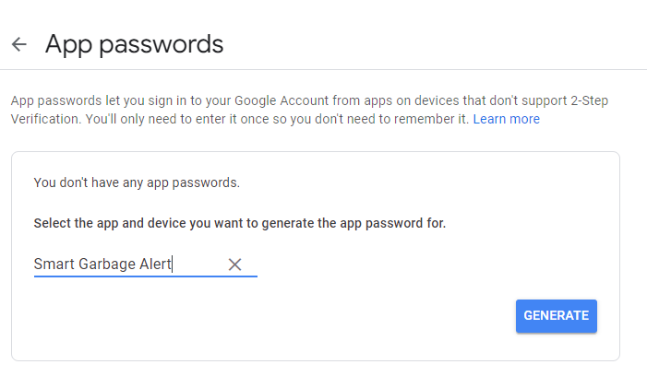

Provide a name for you App that will be using this App Password

Click GENERATE

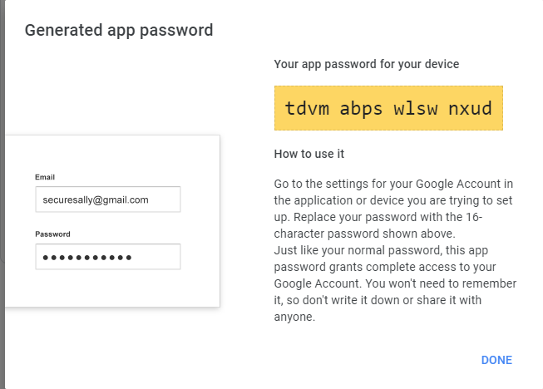

Your App Password is now created.

Copy and pass it somewhere

You will need this in your program to send email without changing the security features of your gmail account.

Click DONE.